**A Complete Reinforcement Learning System**

**Nguyễn Hoàng Việt – QE170216**

**AI17C**

**REL301m**

1. **Certificate**

Link: <https://coursera.org/share/05f5b4c245824afa92867fcdb7cb62cb>

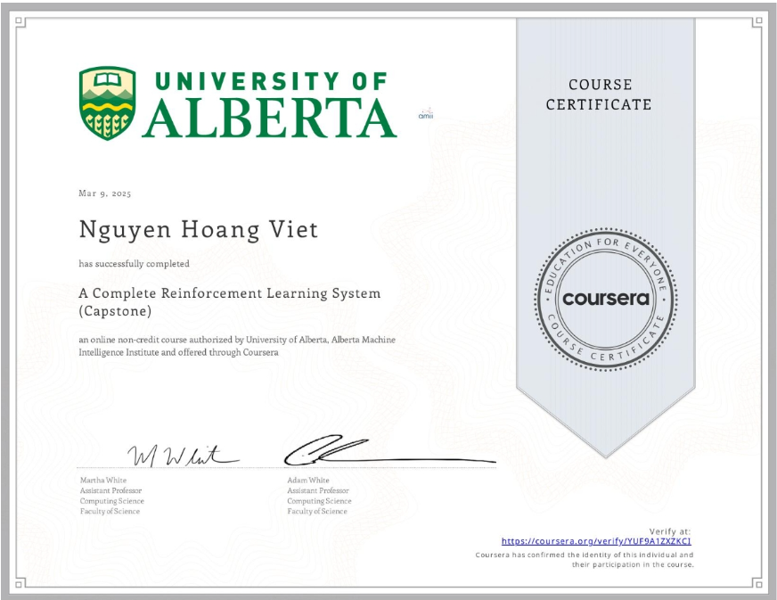

1. **Assignment**

* **MoonShot Technologies**: [link github](https://github.com/nguyen-hoang-viet/reinforcement-learning-course/blob/main/assignment/course%204/MoonShot_Technologies.ipynb)
* **Implement Your Agent:** [link github](https://github.com/nguyen-hoang-viet/reinforcement-learning-course/blob/main/assignment/course%204/Implement_Your_Agent.ipynb)
* **Completing the parameter study:** [link github](https://github.com/nguyen-hoang-viet/reinforcement-learning-course/blob/main/assignment/course%204/Completing_the_parameter_study.ipynb)

1. **Quiz**

* Choosing the Right Algorithm

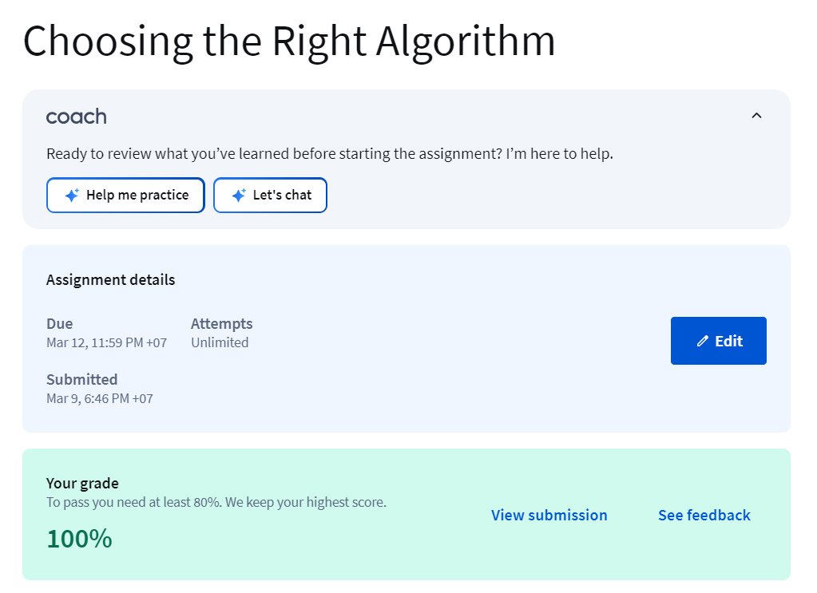

* Impact of Parameter Choices in RL

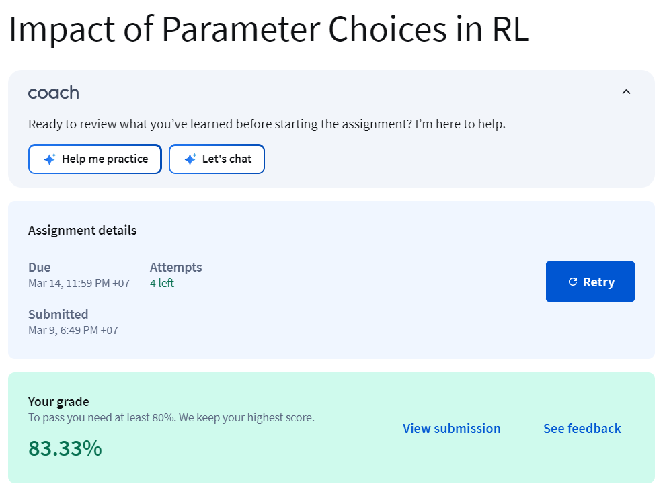

* Total:

